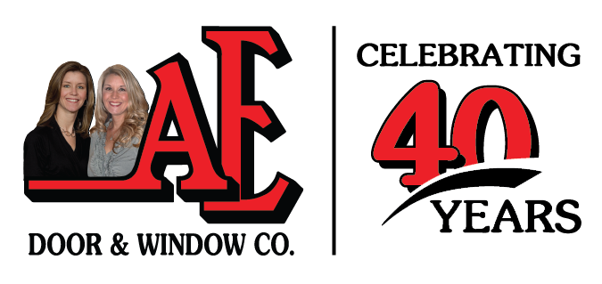

AE Door and Window is currently monitoring the developments related to the COVID-19 outbreak. We want to ensure you we are doing everything possible to protect the health and safety of our customers, employees and their families. We are currently operating business as usual in the midst of our 40th anniversary celebration. We are fully staffed and ready to help you with any of your garage door, entry door, window, awning and service needs.

We have instructed all of our employees to take basic precautionary steps to help prevent the transmission of COVID-19. This includes closely following guidance from the CDC regarding hand hygiene, respiratory etiquette and encouraging employees to stay home when sick. Everyone at AE Door and Window is committed to providing the level of service our customers have come to expect from us. Even in these difficult times, we will continue to
“Sell the Best… And Service the Rest.”

